TITLE
Surname A^{a*}, Surname FN^{b}…..
ªInstitution A, XXX, Location, Country
^{b}University XXX, Location, Country

Abstract
A single paragraph of about 500 words maximum. For research articles, abstracts should give a pertinent overview of the work. We strongly encourage authors to use the following style of structured abstracts, but without headings: (1) Background: Place the question addressed in a broad context and highlight the purpose of the study; (2) Methods: briefly describe the main methods or treatments applied; (3) Results: summarize the article's main findings; (4) Conclusions: indicate the main conclusions or interpretations. The abstract should be an objective representation of the article and it must not contain results that are not presented and substantiated in the main text and should not exaggerate the main conclusions.

© 2022 The Authors. Published by Cardiff University Press.
Selection and/or peer-review under responsibility of Cardiff University

Keywords: Keyword 1, Keyword 2, Keyword 3, Keyword 4, Keyword 5.

Introduction
Title 1 | Title 2
entry 1 | data
entry 2 | data
The introduction should briefly place the study in a broad context and highlight why it is important. It should define the purpose of the work and its significance. The current state of the research field should be carefully reviewed and key publications cited. Please highlight controversial and diverging hypotheses when necessary. Finally, briefly mention the main aim of the work and highlight the principal conclusions. As far as possible, please keep the introduction comprehensible to scientists outside your particular field of research. References should be numbered in order of appearance and indicated by a numeral or numerals in square brackets—e.g., [1] or [2,3], or [4–6]. See the end of the document for further details on references.

Materials and Methods
The Materials and Methods should be described with sufficient details to allow others to replicate and build on the published results. Please note that the publication of your manuscript implicates that you must make all materials, data, computer code, and protocols associated with the publication available to readers. Please disclose at the submission stage any restrictions on the availability of materials or information. New methods and protocols should be described in detail while well-established methods can be briefly described and appropriately cited.
Research manuscripts reporting large datasets that are deposited in a publicly available database should specify where the data have been deposited and provide the relevant accession numbers. If the accession numbers have not yet been obtained at the time of submission, please state that they will be provided during review. They must be provided prior to publication.
Interventionary studies involving animals or humans, and other studies that require ethical approval, must list the authority that provided approval and the corresponding ethical approval code.

Results
This section should provide a concise and precise description of the experimental results, their interpretation, as well as the experimental conclusions that can be drawn.

Figures, Tables and Schemes
All figures and tables should be cited in the main text as Fig. 1 (unless it is the beginning of the paragraph, in which case it should be Figure 1), Table 1, etc.
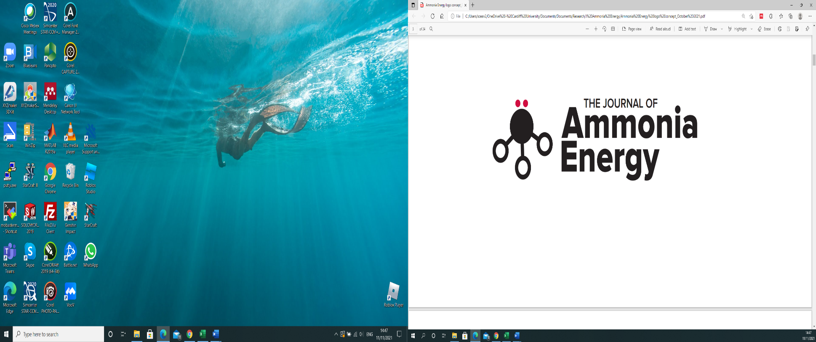
Fig. 1. The Journal of Ammonia Energy

Table 1. This is a table. Tables should be placed in the main text near to the first time they are cited.

The text continues here (Figure 2 and Table 2).

Equations should be formatted using Word Equations Tool.

Discussion
Authors should discuss the results and how they can be interpreted from the perspective of previous studies and of the working hypotheses. The findings and their im-plications should be discussed in the broadest context possible. Future research direc-tions may also be highlighted.

Conclusions
This section is not mandatory but can be added to the manuscript if the discussion is unusually long or complex.

Acknowledgments
In this section, you can acknowledge any support given which is not covered by the author contribution or funding sections. This may include administrative and technical support, or donations in kind (e.g., materials used for experiments).

Conflicts of Interest
Declare conflicts of interest or state “The authors declare no conflict of interest.” Authors must identify and declare any personal circumstances or interest that may be perceived as inappropriately influencing the representation or interpretation of reported research results. Any role of the funders in the design of the study; in the collection, analyses or interpretation of data; in the writing of the manuscript, or in the decision to publish the results must be declared in this section. If there is no role, please state “The funders had no role in the design of the study; in the collection, analyses, or interpretation of data; in the writing of the manuscript, or in the decision to publish the results”.

Appendix A
The appendix is an optional section that can contain details and data supple-mental to the main text—for example, explanations of experimental details that would disrupt the flow of the main text but nonetheless remain crucial to understanding and reproducing the research shown; figures of replicates for experiments of which representative data is shown in the main text can be added here if brief, or as Supplementary data. Mathematical proofs of results not central to the paper can be added as an appendix.

References
References must be numbered in order of appearance in the text (including citations in tables and legends) and listed individually at the end of the manuscript. We recommend preparing the references with a bibliography software package, such as EndNote, Reference Manager or Zotero to avoid typing mistakes and duplicated references. Include the digital object identifier (DOI) for all references where available.
Citations and references in the Supplementary Materials are permitted provided that they also appear in the reference list here.
In the text, reference numbers should be placed in square brackets [ ] and placed before the punctuation; for example [1], [1–3] or [1,3]. For embedded citations in the text with pagination, use both parentheses and brackets to indicate the reference number and page numbers; for example [5] (p. 10), or [6] (pp. 101–105).

1. Author 1, A.B.; Author 2, C.D. Title of the article. Abbreviated Journal Name Year, Volume, page range.
2. Author 1, A.; Author 2, B. Title of the chapter. In Book Title, 2nd ed.; Editor 1, A., Editor 2, B., Eds.; Publisher: Publisher Location, Country, 2007; Volume 3, pp. 154–196.
3. Author 1, A.; Author 2, B. Book Title, 3rd ed.; Publisher: Publisher Location, Country, 2008; pp. 154–196.
4. Author 1, A.B.; Author 2, C. Title of Unpublished Work. Abbreviated Journal Name stage of publication (under review; accepted; in press).
5. Author 1, A.B. (University, City, State, Country); Author 2, C. (Institute, City, State, Country). Personal communication, 2012.
6. Author 1, A.B.; Author 2, C.D.; Author 3, E.F. Title of Presentation. In Title of the Collected Work (if available), Proceedings of the Name of the Conference, Location of Conference, Country, Date of Conference; Editor 1, Editor 2, Eds. (if available); Publisher: City, Country, Year (if available); Abstract Number (optional), Pagination (optional).
7. Author 1, A.B. Title of Thesis. Level of Thesis, Degree-Granting University, Location of University, Date of Completion.
8. Title of Site. Available online: URL (accessed on Day Month Year).

